

FINAL REPORT

Design Studio #4

Instructor: Gülbin DURAL

Members:

* Fatih ÇALIŞ
* Fatih ÇAM
* Recep GÜNAY
* Huzeyfe HİNTOĞLU
* Sarah ILYAS

Table of Contents

1- Executive Summary 3

2- Design Description 3

2-1. Transmission Subsystem 8

2.2- Electromechanical, Mechanical Subsystem 12

2.3- Shooting Mechanism 15

2.4- Control Subsystem 17

2.5- User Interface Subsystem 18

3- Results and Analyses Of Performance Tests 19

4- List of Deliverables 21

5- Budget Breakdown 21

6- Discussions 22

6.1- Safety Issues 22

6.2- Applications 23

6.3- Potential Environmental Effects 23

7- Conclusion 23

Appendices 25

User Manual 25

Warranty 25

The Robot 26

The Radio Controller 26

The Video Receiver 27

The Battery 27

GoFPV App 27

# Executive Summary

Every day, an average of **15** people ARE newly diagnosed with ALS — more than **5,600** people per year. The average life expectancy of a person with ALS is two to **five** years from the time of diagnosis. We, as enterprising engineers at Automata Technologies have taken quantum leaps to assist the latter through teleoperated robotics. Our aspirations materialized into a full-blown and sophisticated system that meets the standards and requirements that have been laid out and conforms to the expectations and budget of the prospective customers. For our venture capitalists and prospective customers, we have put together the entire requisite information in this exhaustive and comprehensive report.

The product developed is a teleoperated robot that aims to mimic a hockey player; the robot, is placed in a hexagonal playfield and is controlled virtually by players that are in contention from upto 30 meters.

To facilitate an effective and successful design, a comprehensive list of customer requirements was transformed into quantitative engineering specifications. The design process in its entirety is detailed throughout this report, including methodology, procedures, analyses, and end results. A detailed description, including finalized CAD models of components is provided as well. The design has evolved throughout the process and the current design is the result of meticulous engineering analysis. This report serves to document the entire process from initial background research to final recommendations for improvement to the final design.

This report documents the entire design process including the final manufacturing plan, the measures taken to ensure that all established customer requirements and engineering specifications have been validated and satisfied in the final prototype, a detailed description and analysis of every major component, and finally, an in depth critique of the functionality of the these components.

# Design Description

The breakdown of the entire system is; Transmission subsystem, electromechanical and mechanical Subsystem, shooting mechanism, Control, sensor and user interface subsystem. The following functional decomposition provides a general overview of the project purpose and the expected components. Its simple format helps to easily depict what the project must accomplish and then helps outline viable design solutions.

The robot in this project is a tele-operated robot that tries to score by pushing or hitting a ball into the opponent’s goal, directly or indirectly. The operator remotely controls the robot (from a distance up to at least 30 meters) without actually monitoring the playfield with naked eye; the only means of monitoring the field is by means of a camera mounted on board the robot.

The operation of the robot can be classified into 2 modes: Attack mode and the Defense mode. Although most of the operations in these modes are the same, to simplify and improve the control of the robot, some minor differences were implemented. The user switches between these modes by using a button on the RC.

In both modes, the FPV camera streams the video that is seen by the robot to the monitor. The user tries to control the robot by watching the live video and by using a RC. The user is able to control the speed and rotation direction of the robot via one of the joysticks of the RC and control the angle of the FPV camera via other joystick. The shooting mechanism is activated by one of the switches of the RC.

In attack mode, the user tries to get robot move forward and aim to the opponent’s goal. After that, the shooting mechanism will be triggered and the robot shoots. In the defense mode, the robot rotates 90 degrees to be able to save its goal more effectively and the FPV camera rotates to the other direction by 90 degree to see the ball in a better way. In this mode, the user has a more chance to prevent its opponent from a score since the robot is able to move forward and backward faster than the attack mode.

The system is composed of five subsystems that are Transmission Subsystem, Mechanical and Electromechanical Subsystem, Control Subsystem, Sensor Subsystem and User Interface Subsystem. The block diagram that shows the connection types and the connections between the subsystems are shown in Figure 1.

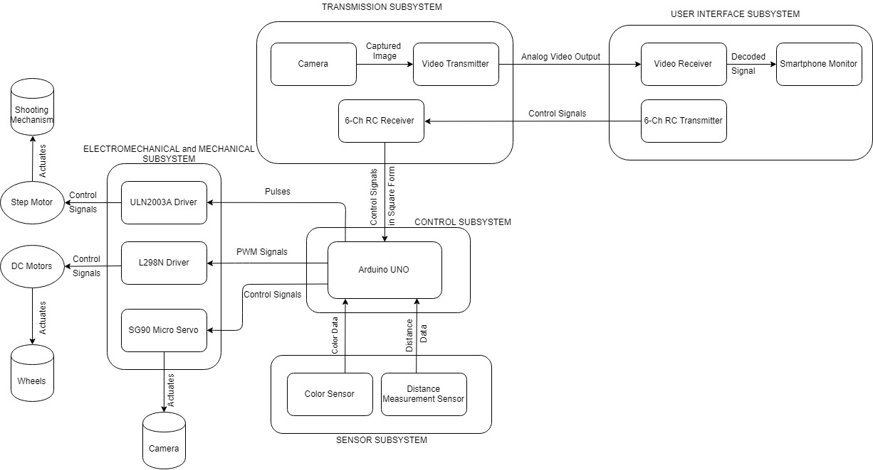

*Figure 1: Overall description of the system with a block diagram including sub-system interaction and interfaces*

Transmission subsystem is composed of camera, video transmitter, and RC Receiver. Camera captures images and send them to transmitter. Transmitter creates analog video output and sends it to user interface subsystem. RC receiver is used to get actuator signals from user interface subsystem to control the robot.

User interface subsystem has video receiver, smartphone screen, and RC transmitter. Receiver gets analog video input from transmission subsystem and decodes it. Then it sends these decoded signals to screen in displayable format. Using and adapter between them, smartphone screen displays live video stream that comes from robot. RC transmitter here is utilized to send actuator signals to transmission subsystem to control robot.

Control subsystem is the brain of all system and it has Arduino as the controller. Arduino reads sensor data from sensor substem and evaluates them for future actions. It gets control signals in square form from transmission subsystem. The controller evaluates these signals to move robot. Arduino creates pulses for step motor driver to stimulate shooting mechanism, pwm signals for DC motor driver to actuate DC motors, and control signal for servo motor to rotate camera.

Sensor subsystem contains color sensor and distance measurement sensor. Color sensor is used for line detection, and distance measurement sensor is utilized in order not to hit walls.

Electromechanical and mechanical subsystem consist of motor drivers and motor. DC motor driver gets signals from controller and creates control signal to drive shooting DC motor. DC motor driver converts pwm signals to control signal to drive DC motors, and Micro Servo directly takes control signals from Arduino to move camera. The general operation flowchart of the robot is shown in Figure 2.

The design of the robot is done considering the fact that the width of the goal is equal to the maximum dimension of the robot multiplied by 2. Therefore, the robot is designed to be as small as possible. However, since the shooting mechanism needs a long rod, it limits the minimum dimensions of the robot. The robot is designed using Autodeslk fuison software and the 3D design of final expected product is depicted in Figure 3.

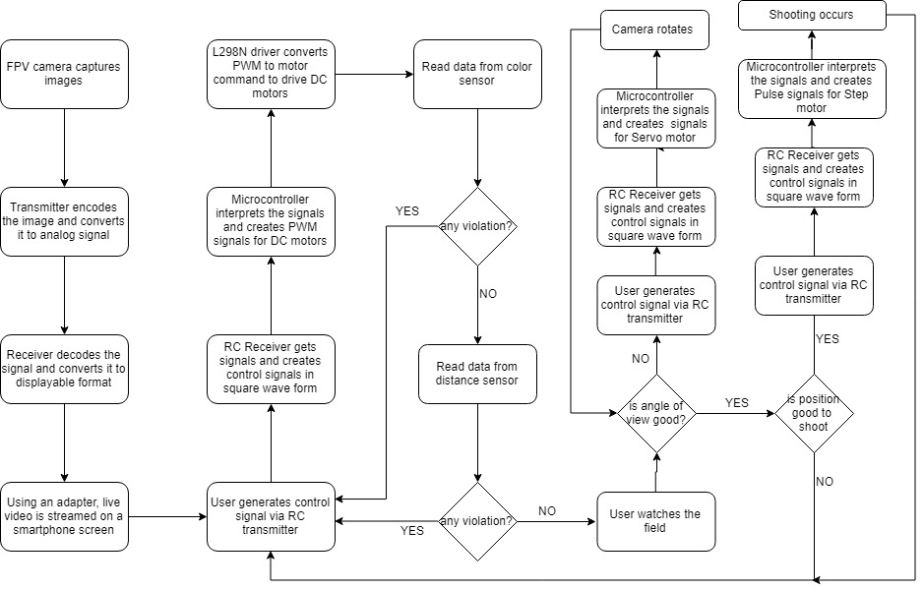

*Figure 2: The main operation flowchart of the system*

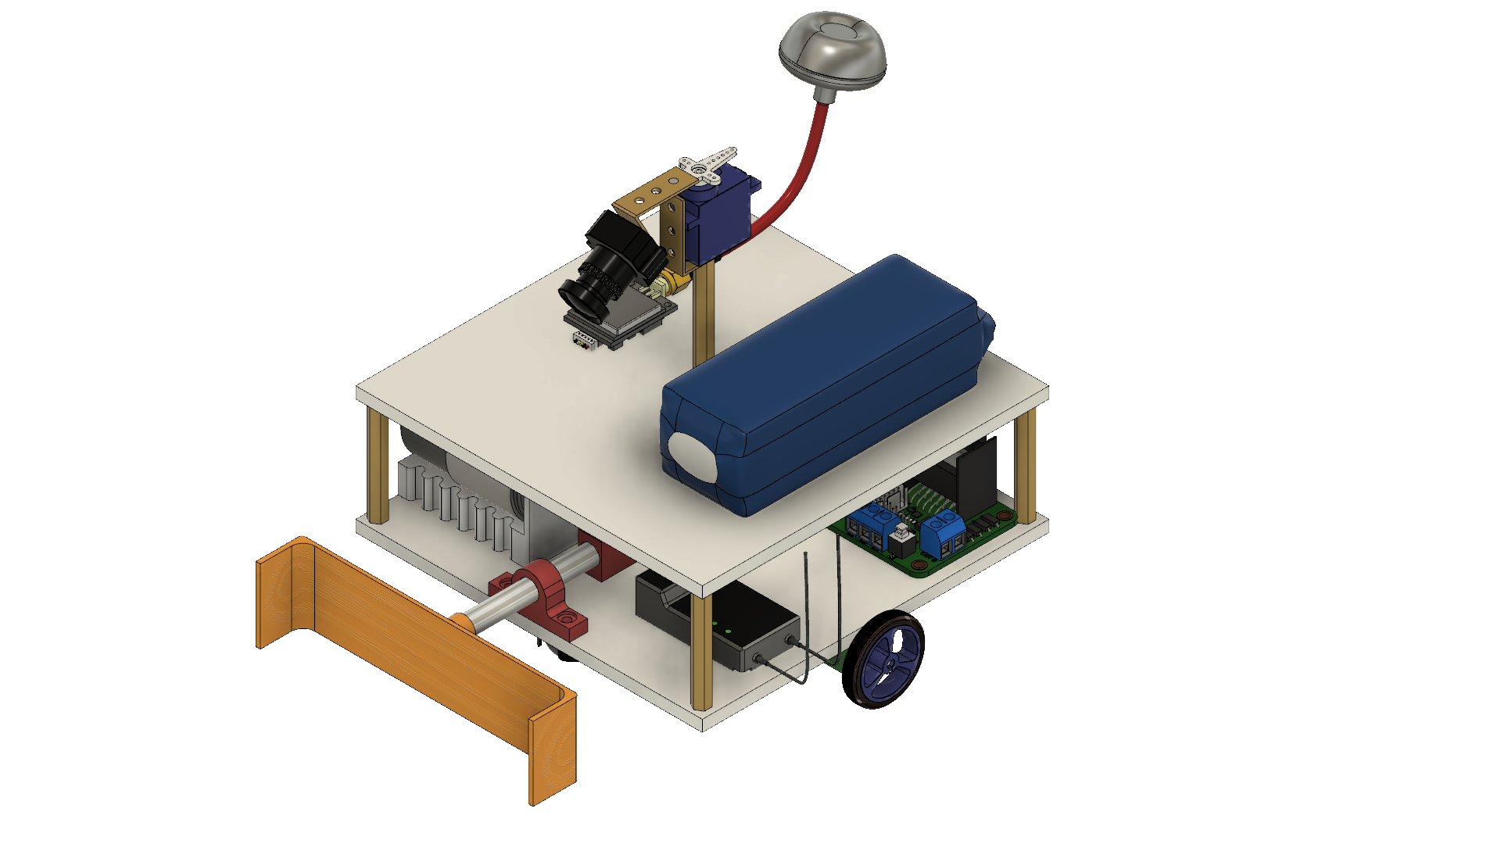

*Figure 3: The 3D drawing of the final design of the robot*

## 2-1. Transmission Subsystem

As mentioned before, the operator controls the robot from a distance up to at least 30 meters. Therefore, the operator monitors the field by camera mounted on the robot. This requires live video stream with enough resolution and low latency for proper operation. for live video stream FPV camera set is used. An FPV camera set is composed of a camera, an analog video transmitter with antenna, and a receiver. Since, the FPV cameras work on analogue video, their resolution is measured in TV lines or TVL rather than pixels. There are some options for TVL such as 420, 480, 600, 800 and 1000. Latency is another factor, which highly depends on both the distance and the quality of the transmitted video. It is usually around 50ms, which is ideal for our project. The transmitter basically processes the image that is captured by the camera and encode this data into an analog signal with a high frequency.

Considering the obstacles that are put on the area, 5.8 GHz is used for our project to transmit live video. The receiver decodes the signal that is radiated by the transmitter and convert this data into a displayable format. After this conversion, a screen is used to convert the data into a video. A smartphone is used as the screen. We utilize an adapter between receiver and smartphone. One of the most important specification of the video transmission is the transmitter output power. The transmitter output should be powerful enough so that the video signal can penetrate through walls up to 30 meters. However, it should be at the minimum power specification so that it does not cause a lot interference when reflected from the walls, it is not be unnecessarily expensive, and it does not cause interference for the other teams that might be using a similar set-up. The transmitter also has many channels in the bandwidth to choose from in order to differentiate the video signal from the signals of other teams. In order to meet the requirements about the range, we increased the transmitter output power. In theory, in order to double the range, the transmitter output power should be quadrupled since the power is dissipated in other directions from the target direction [1]. However, the range dependence on the transmission power is even less in practice due to noise and attenuation in all directions , and also increasing the transmitter output power may cause other issues such as overheating of the transmitter module, interfering with other teams and multipath interference caused by the waves reflecting from the obstacles. In order to solve the multipath interference problem, circularly polarized waves are utilized in the transmission.

The video receiver is also a very important factor in the video transmission system. A good receiver has a high sensitivity of signal power. Furthermore, diversity type receiver is used for the continuity of the transmission since a diversity type receiver has two receiver modules inside. The two receiver modules have separate antenna inputs and the outputs of the receivers are compared according to the received signal strength [2]. The output of the receiver modules which has the greater strength is connected to the output of the overall circuit which feeds into the monitor. The operation principle of a diversity receiver is shown in Figure 4.

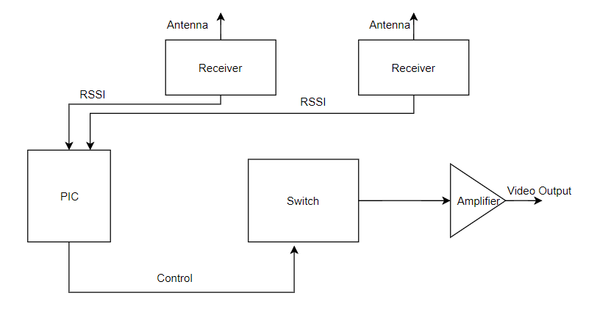

*Figure 4: The block diagram of a diversity receiver.*

Even though the diversity receiver system seems very sound in the operation, it has some flaws such as when the input antenna is changed, there might be a cut in the video for a short duration and the phase difference between the signals received from two antennas since there is a finite distance between the antennae. However, these issues do not cause much of a problem for the overall operation since the speed of operation is negligibly small compared to the magnitude of these problems.

The other important parameter of the video transmission system is the antennae namely, the antenna of the transmitter and the antennae of the receiver. We have used circularly polarized antenna in the system since the polarization direction changes when a circularly polarized electromagnetic wave reflects from an object. The antennae on both the transmitter and receiver are of the same polarization direction that is right hand circularly polarized (RHCP) or left hand circularly polarized (LHCP) so that the wave portion that reflects from an object does not cause an interference since the antenna ignores a wave with another polarization direction. Furthermore, the antenna on the transmitter is of omni-directional type giving equal amount of gain in all directions since the robot moves in different directions and the wave propagates from different directions. The advantage of using a diversity receiver comes out at this point since we have the capability of using two antennae on the receiver. We used one omnidirectional antenna and one directional antenna with a relatively high gain in order to have gain in all directions and a high gain in direction to increase the gain in that direction [3]. The radiation patterns of an omni-directional antenna and a directional antenna are shown in Figure 5 and in Figure 6, respectively.

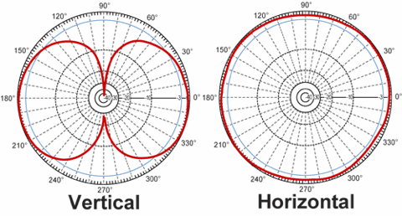

*Figure 5: The radiation pattern of an omni-directional antenna.*

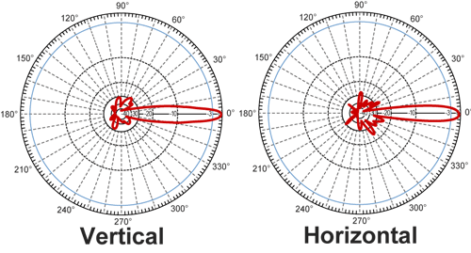

*Figure 6: The radiation pattern of a directional antenna.*

## 2.2- Electromechanical, Mechanical Subsystem

Electromechanical subsystem is composed of motors and motor drivers. Basically, it is responsible for moving parts of the robot. For instance, movement of the overall chassis, alignment of camera on board according to position of the robot and shooting mechanism control and movement.

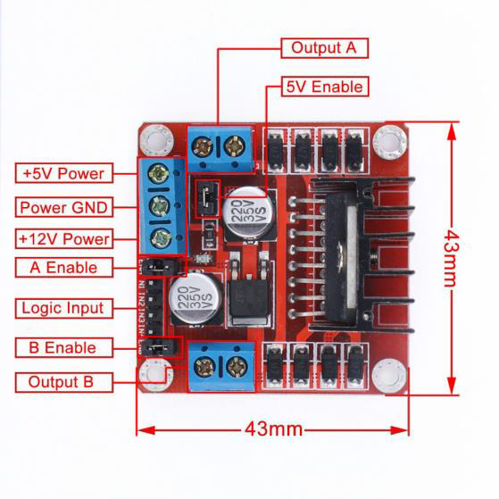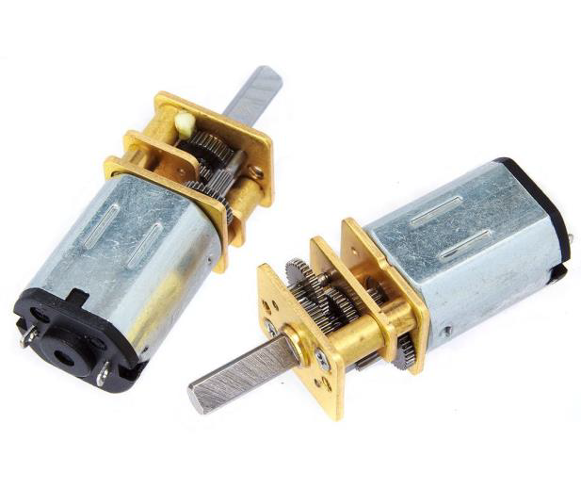

*Figure 7: L298N motor driver and DC motor*

We have used DC Brushed motors and L298N motor driver (H- Bridge). These components are commonly used for this purpose and easy to use and they are illustrated in Figure 6. DC motors are operating at 6V and 350 rpm in the free-run speed and works with 60mA continuous current. The maximum forcing current for the motors are 1.3A and the maximum torque to be obtained is 1.8 kg-cm [4]. L298N is used for driving these 2 DC motors synchronously. It is suitable for our project with the specifications that it has current capacity for each motor up to 2A and 6V-15V motor driving capability. It also has lots of analog and digital I/O ports which will be connected to controller via jumper cables easily.

In the main chassis movement, there are two DC motors, two wheels, one free turning wheel and one DC motor driver. Two wheels connected to DC motors are implemented to the left and right sides of the robot. Free turning wheel is implemented to the front side of the robot. The movements are achieved by the differential wheels.

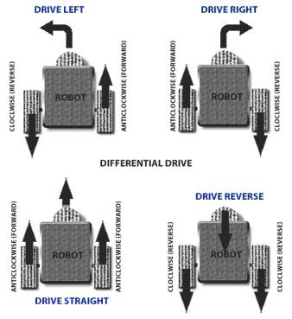

*Figure 8: Robot movements with 2 Motors*

Operation principle of differential wheels are simple. If both the wheels are driven in the same direction and speed, the robot goes in a straight line. If both wheels are turned with equal speed in opposite directions, as is clear from the diagram shown in Figure 8, the robot rotates about the central point of the axis [5]. While turning the robot to one direction, either one motor is driven through forward and other to backward or both in the same direction with different speeds. Since the direction of the robot is dependent on the rate and direction of rotation of the two driven wheels, these quantities are sensed and controlled precisely.

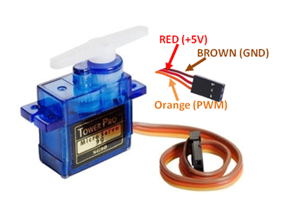

*Figure 9: TowerPro SG90 Micro DC Servo Motor*

Moreover, we have used servo motor that is connected to camera the on the robot so that we can move the camera to have a better sight. This also plays very important role for the project because we must have as better sight as possible to make proper movements with the robot in order to reach the ball and act on time. TowerPro SG90 Micro Servo is used for these purposes. It is a low-cost plastic gear RC servo with 1.80kg.cm holding torque (at 4.8V). The servo is illustrated in Figure 9.

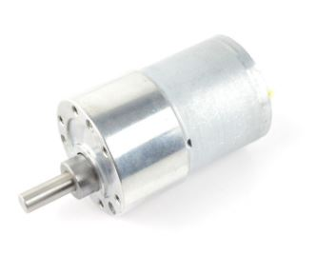

*Figure 10: 30 RPM DC Motor*

In the spring system, we used a low rpm DC Motor for triggering system as mentioned in shooting mechanism subsystem part and it is shown in Figure 10. We used a 30 rpm DC motor to compress the spring using a gear described in the shooting mechanism subsystem and we used a mosfet to drive the motor. This motor has a high torque and low rpm making it easy to control and shoot hard.

## 2.3- Shooting Mechanism

A shooting mechanism that employs a spring has been very powerful because, depending on aptly selected parameters, a spring can store inordinate amounts of energy. A system such as this therefore is able to shoot the ball with high velocity. Moreover, the number of shots that can be made by virtue of this setup is very high compared to other methods because each shot requires small amount of energy. On the other hand of the spectrum, however, the system also has its setbacks, it is difficult to implement it mechanically and it takes a while to reload. When the power consumption is considered, these are the problems have been solved easily rather than energy problem. As a result, a mechanical shooting mechanism, namely spring-based shooting mechanism, has been implemented. The Figure 11 below depicts the general structure of our spring-based shooting mechanism and its components.

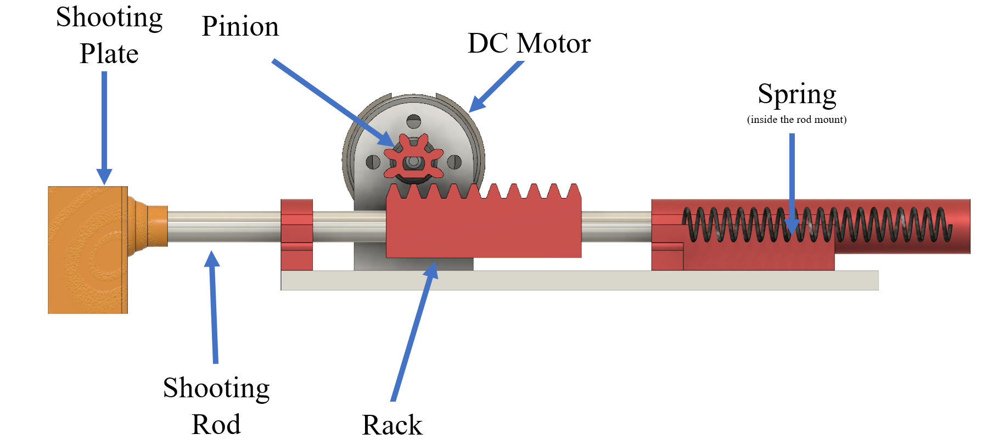

*Figure 11: The elements of the spring-based shooting mechanism*

There is a triggering component, a DC motor, to compress the spring and store energy onto it mechanically. When the triggering command come by user, it starts to operate. While the shaft of the DC motor is rotating, the pinion also rotates since they are mechanically coupled. This rotation causes the rack to slide such that the spring is compressed. After the one full rotation of the pinion, the cogs of the rack become free and thus, spring is suddenly released, meaning that shooting is achieved. Shooting power and velocity of the ball is tested and the mechanism is optimized by changing the length of the spring accordingly.

The torque of the DC motor directly affects the compression of the spring and thus the shooting velocity. Therefore, we have used a high torque-low RPM DC motor. Also, the mounting of the motor has great importance since due to the force generated by the spring, there is a torque on the pinion to force the DC motor to rotate its lateral axis, which is not desired. To fix the motor well and to prevent this problem, we have used a metal motor mount. The rod mounts are placed to make sure that shooting rod slides in shooting axis smoothly. The shooting plate is designed such that the shooting operation is achieved easily by the user. The overall configuration of the shooting mechanism is shown in Figure 12.

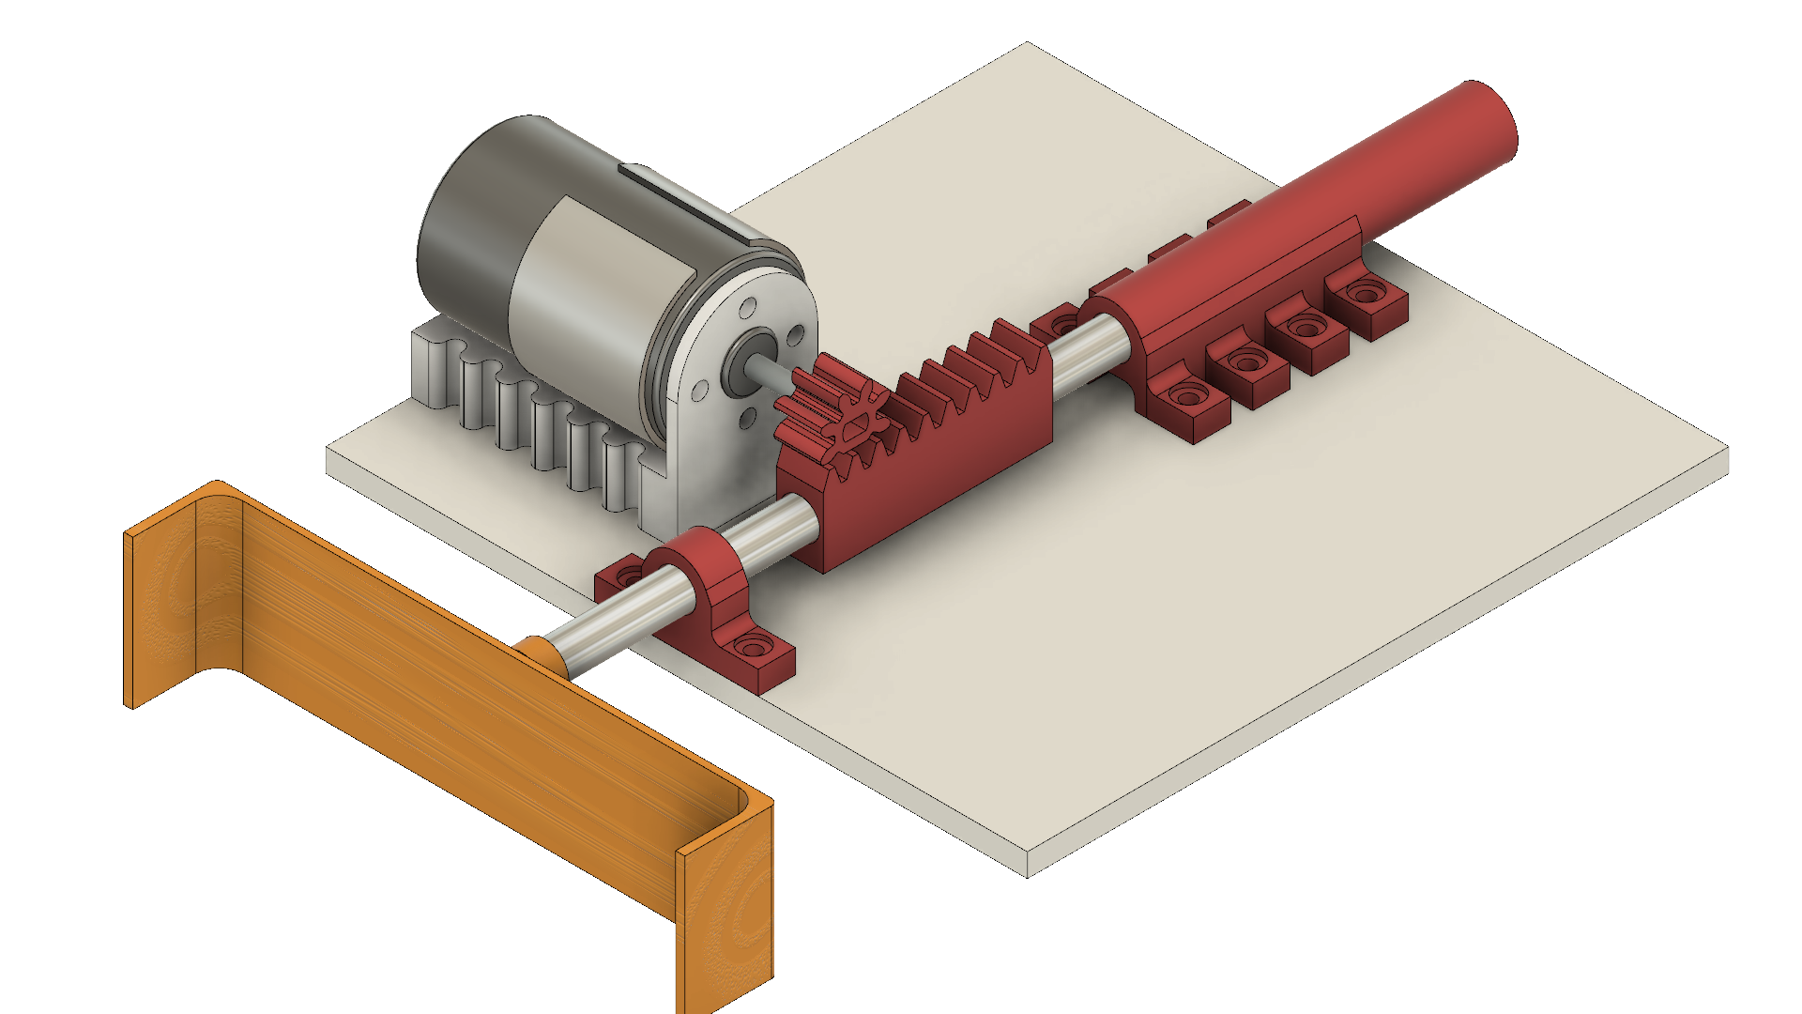

*Figure 12: 3D model of shooting mechanism*

## 2.4- Control Subsystem

Control subsystem consists of two parts. One is remote control device and the other one is microcontroller. For the remote-control device, we have used using 6-Ch RC Transmitter & Receiver. We have used 2 channels for controlling the robot movements, 1 channel for adjusting the camera angle, and the one channel for shooting. This device has been quite practical and convenient for the project. It is in low power consumption for durable using. It also has high receiving sensitivity.

For the on-board control purposes, the use of a microcontroller is inevitable. In the market, there are so many different microcontroller boards with different properties. Due to its simplicity and popularity, we used an Arduino NANO. It has clock frequency of 16MHz, variable input voltage between 7 and 12V, analog input pins and PWM output pins, apart from the digital GPIO pins. The Arduino NANO is shown in Figure 13.

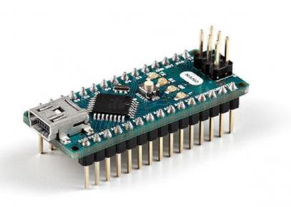

*Figure 13: The Arduino NANO with the GPIO pins soldered to the male headers*

The main mission of the Arduino is to get the signal (sent by the user through RC transmitter) from the receiver and generate the required motor commands according to instructions. These instructions come from the 4 channels of the RC transmitter and delivered to the Arduino via receiver in the form of a square wave. These 4 signals have the period of 20 ms and their duty cycle vary depending on the position of the joysticks in the RC transmitter. When the joystick is at the maximum position, the transmitted signal has the ON time of 2ms, corresponding to 10% duty cycle. At the minimum position, the ON time is 1ms resulting in the duty cycle of 5%. Thus, by calculating the ON time of the incoming 4 signals, the Arduino generates the desired motor commands. These signals are delivered to the motors accordingly. In the case of the main DC motors, which are responsible for the positioning of the robot, the motor command changes instantaneously in analog manner according to the incoming signals. This action is valid for the Servo motor as well, the purpose of which is to rotate the FPV camera. However, in case of the shooting action, since the motor inside the shooting mechanism does not need to turn continuously, the motor command is generated for some period, according to the digital shooting signal.

To sum up, control subsystem’s function is that RC Transmitter sends the signals to the receiver that is on the robot, then the receiver generates pulses and sends them to the microcontroller and finally microcontroller interprets these signals and generate commands for the robot. At the end, the robot moves according to the instruction that is sent by the operator and shoots the ball whenever the shoot button is pressed on the RC transmitter.

## 2.5- User Interface Subsystem

In the interaction of the user with the system, we have used a controller and monitoring subsystems as user is not allowed to see the playing field with naked eye. The user needs to see the information coming from the robot on a display screen. For this purpose, a smartphone is used. This setup is tested several times and it is working really well. By this way, anyone is able to play the game anywhere.

For the control of the robot, the user is able to have a device to steer the robot and issue commands. For this purpose, RC controller is used as mentioned in the Control subsystem part. RC controller is reliable and user friendly since there are control buttons for steering of the robot and the camera and shooting requiring different channels for each control. The experiment with an RC controller was performed along with the transmission subsystem in different conditions and the results are even better than the video transmission. The RC controller can send commands with little to no delay up to 100 meters with obstacles between the robot and the user

# Results and Analyses Of Performance Tests

We have tested the shooting mechanism by building the prototype system given in Fig. 14.

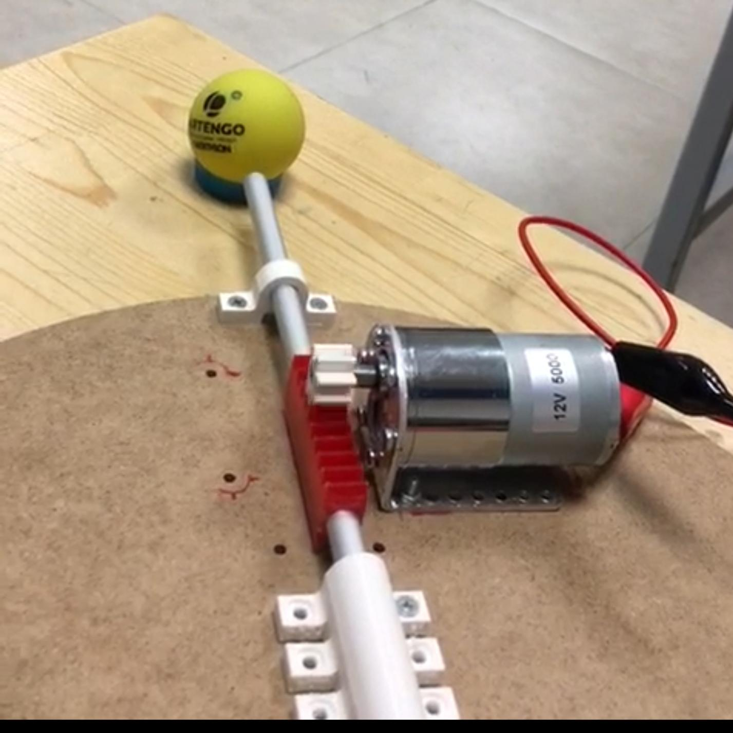

*Figure 14: The test prototype of the shooting mechanism.*

After the tests, we have realized that the shooting mechanism operates as desired. A complete shot is realized in around 2 seconds. The shooting action will be controlled by a switch and it continuously shoots in every 2 seconds unless the user switches back.

For the testing of the transmission subsystem, we prepared a number of test mechanisms to characterize the transmission in different specifications such as range, latency and interference. In order to test the latency of the transmission, we took a photograph of a timer together with the live video stream of the timer and measured the difference between the times as shown in Figure 15. In the shown setup, the transmitter and the receiver were very close to each other and there were no obstructions between them, and the latency was measured to be 80ms which is negligible since the reaction time of a human is 0.25s for a visual stimulus. We tested the latency when the transmitter and the receiver are as far away from each other as 20m and we observed that the increase in the latency with distance is almost negligible since it did not even reach 100ms. We could not test the latency with walls between the transmitter and receiver using this setup, however, we tested it using the reaction time of a human and we could not distinguish a difference between the real timer and the video of the timer.

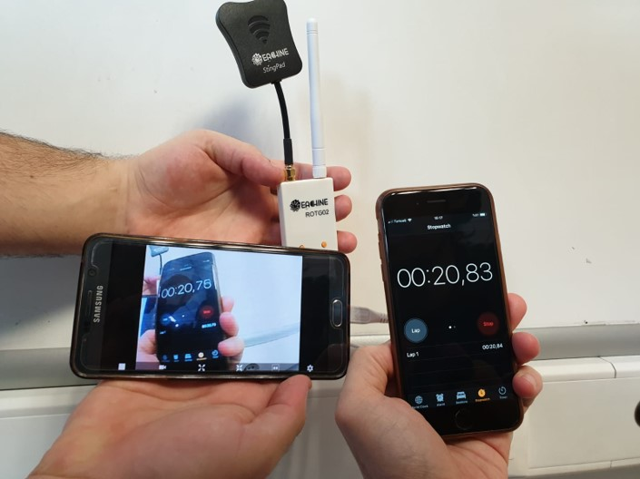

*Figure 15: The test method to measure latency in video transmission*

For testing the range of the video transmission, we experimented in different environments and over different distances. The upper limit of the video transmission range in line of sight could not be found exactly because it is much longer than 30m. However, when there are walls and obstacles between the transmitter and receiver, the range goes up to 40m with bad quality video. Furthermore, we tested when the transmitter was turned around itself and the result is the same since the antenna on the transmitter is an omni-directional antenna.

For testing the interference within the system and with other teams, we performed the experiments inside a reflective environment. We observed very little drop in the video quality due to multipath interference. However, the effect of the multipath interference is kept at minimum by making use of circularly polarized waves. Also, we ran the system while another transmission system was working in the same environment. We observed no interference with the other system since we use multi-channel transmission system and we are safe as long as the channels are different from each other. The system has also been tested during the demonstration to the design coordinator when there were other groups also demonstrating and there was no problem with interference and range.

The experiment with an RC controller is performed along with the transmission subsystem in different conditions and the results are even better than the video transmission. The RC controller is able to send commands with little to no delay up to 100 meters with obstacles between the robot and the user. It is tested by using a commercially available RC transmitter of FlySky-i6. This subsystem is also tested during the demonstration and there are no problems regarding delay and range.

# List of Deliverables

The items that will be provided are listed as follows:

* The robot,
* The Radio controller,
* The video receiver,
* A battery,
* Smartphone app to see video from FPV,
* Warranty,
* A user manual.

# Budget Breakdown

The following table enumerates our spendings and budget allocation for the system. Budget analysis was made considering the optimal price over quality ratio. As is evident from the cumulative total, our project did not exceed the $200 limit. It can therefore be deemed as a cost effective entraption. Budget analysis of the project is shown in Table1.

|  |  |
| --- | --- |
| COMPONENT | PRICE |
| Video Transmitter | 13$ |
| Video Receiver | 19$ |
| FPV Camera | 25$ |
| RC Controller | 43$ |
| Battery | 25$ |
| DC Motor (x2) | 10$ |
| Servo Motor | 2$ |
| Shooting DC Motor & Driver | 14$ |
| Chassis (Screws, Plexiglass, 3D Material, Motor Mount, Spacer, Cables) | 13$ |
| Shooting Mechanism (Rod, Spring, Bearing, Rails, 3D Material) | 4$ |
| Motor Driver | 2$ |
| Wheels (x2) | 2.25$ |
| Arduino | 2$ |
| Voltage Regulator | 3$ |
| Ball | 1.5$ |
| Walls | 5$ |
| Caster Wheel | 2$ |
| TOTAL | **185$** |

*Table 1: The budget analysis of the project*

# Discussions

## 6.1- Safety Issues

Some aspects of the design process such as drilling and fibre glass cutting had the potential to jeopardize the safety of the user and therefore such processes were carried out painstakingly and with precaution. Safety goggles, gloves and other paraphernalia were employed to ensure that no harm was done to the user. As meticulous engineers, we deem the health and safety of our customers as our highest priority and therefore we eliminated any element of the design that could be detrimental to the health of our customers.

## 6.2- Applications

Since this project is inherently mimicking a recreational sport, it holds immense potential to be implemented in actual settings by players in a wide age group. Most importantly, it can be implemented in settings where a player has physical disabilities and cannot perform the actual sport out in the open but can partake in it in a somewhat virtual setting. A case in point is Amyotrophic Lateral Sclerosis patients who have very limited motor control. By virtue of this project, however, they can achieve satisfaction that may be comparable to that achieved by playing the actual sport. Also, like any other sport, this sport, in a virtual setting helps sharpen the reflexes of the players; but unlike real sports which may be disrupted by unfavorable pitch conditions owing to rain or other similar environmental conditions, this one will not be impacted by external circumstances or environmental conditions. In addition, this project is also ideal for children who can learn the tricks of the trade for the game earlier on, before setting out on the field.

## 6.3- Potential Environmental Effects

As meticulous engineers, we deem environmental effects as crucial while gauging the impact of our product. When used enmasse, we firmly believe that our product would not be harmful for the environment. There exist no elements in the design that have a propensity to be detrimental to the environment. During the design process itself, no techniques that could adversely impact the environment were employed. Therefore, we can safely claim that our product has no adverse impact on the environment.

# Conclusion

In the realm of teleoperated robotics, there has been an ever-increasing demand for contraptions that can help users achieve more, we at Automata Technologies strive to take quantum leaps in the right direction by integrating innovation with cutting edge technology and thorough research. This venture, wherein we devised a strategy and designed a teleoperated robot is just another case in point. The demands laid out by our clientele were the focal point of our endeavors. By virtue of this document we have shed on each subsystem of our robot, including the transmission, mechanical electromechanical, power, control and sensory subsystems. A lot of thought and planning was invested in the design and selection of each individual sub- block of our project; from the selection of an apt camera that would depreciate latency to choosing an acquisite shooting mechanism that would not be hefty, each individual component was winnowed out from a plethora of other choices after conscious planning, deliberation and research..For our prospective clients, we offer a versatile product. This product may be employed by disparate people, from sport coaches to ALS patients. As pioneers of this company, this is one of the very first technological enterprises we have undertaken and one of our greatest aspirations was to offer the most innovative solution to our consumers. As a nascent and budding company, we are very conscious of the impact we make on our environment; one of the preliminary standards of our company is to ensure that our products create no adverse environmental effects. Conclusively, we at Automata Technologies believe that our product, when used by out clientele, will live up to their expectations; its accomplishment is a notch on our belts.

# Appendices

## User Manual

The provided 2S Li-Po battery should be connected to the corresponding T-plug connector and the switch be turned on to power the robot. The radio controller should be powered using its switch and all the channels should be low to activate the controller. The receiver should be connected to a smart-phone using the appropriate adapter and the GoFPV app should be run to see the video from the robot. The band, channel and power of the transmitter can be changed using the button on the transmitter. The band can be changed by pushing the button, the channel can be changed by holding the button and pushing to change it, and the power can be changed by holding the button longer and pushing to change it. The corresponding parameters to the LED display on the transmitter are shown in the datasheet of the transmitter. The channels can be scanned or adjusted to the exact value using the two buttons on the receiver. The incoming video transmission can be recorded on the app. After adjusting transmission parameters and turning on the robot, the robot can be controlled by using the radio controller. The right joystick controls the movement of the robot, the left one controls the movement of the camera and the digital switch on the upper right controls the shooting mechanism. The movement of the robot is intuitive meaning that by moving the joystick up, the robot is moved forward, by moving it down, the robot is moved backward, by moving it right or left, the robot is rotated around itself to the right or left, by moving it in between these positions, the robot is moved forward or backward turning right or left. The camera movement is controlled by the left joystick, and up is right and down is left. The shooting mechanism is digital, by moving the upper right switch up, the mechanism is activated and the robot shoots continuously and by moving it down, it stops shooting.

## Warranty

As Automata Technologies, we provide a 2-year warranty in the event of a technical failure in the product. We provide technical support and replacement product if a company fault is detected. However, user faults are not included in the warranty.

## The Robot

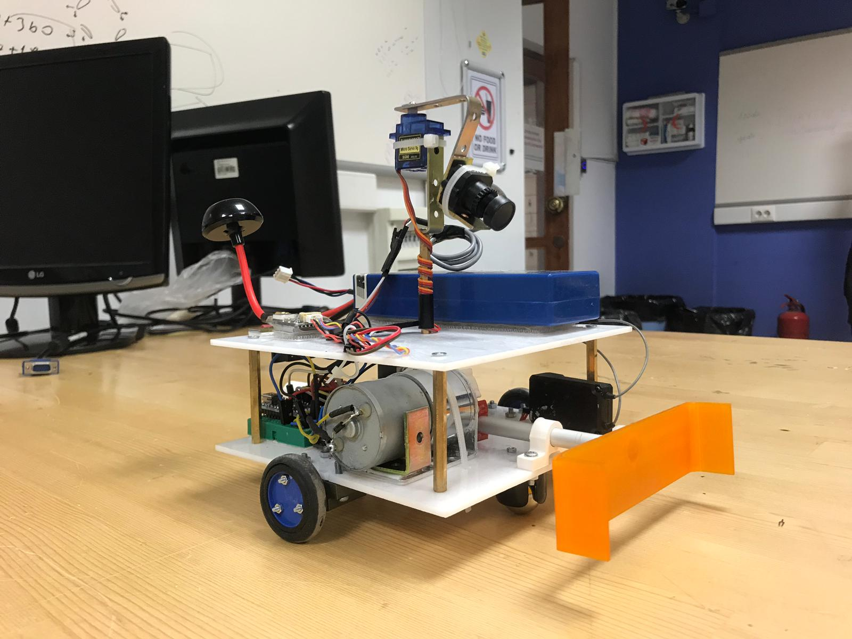

## The Radio Controller

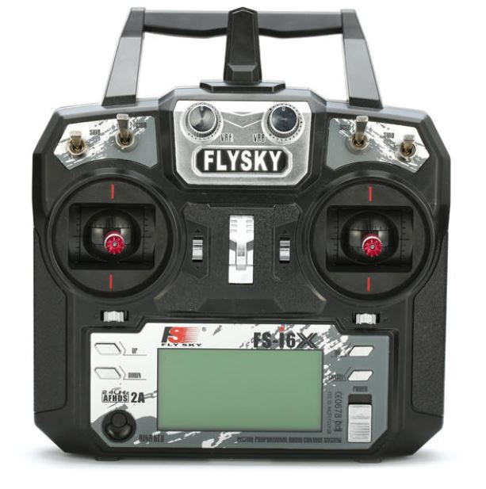

## The Video Receiver

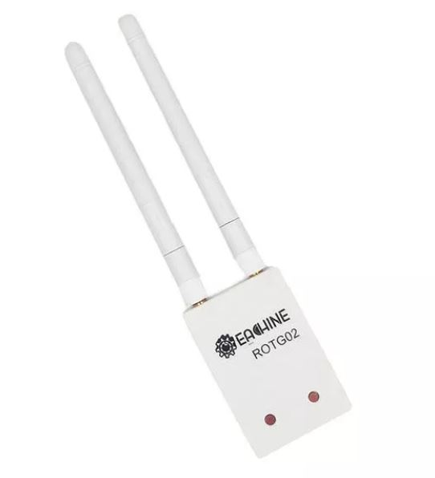

## The Battery

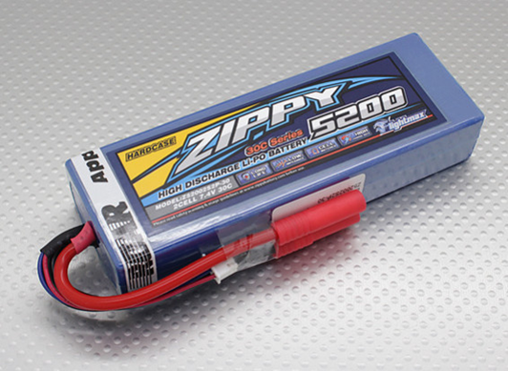

<https://hobbyking.com/en_us/zippy-flightmax-5200mah-2s2p-30c-hardcase-pack-roar-approved-de.html?___store=en_us> ( Battery link)

## GoFPV App

<https://play.google.com/store/apps/details?id=com.vertile.fpv3d&hl=en> (Android App link)